**Story Boarding**

**Smart Home Assistant –** A user interacts with a voice-controlled AI assistant for daily tasks.

**Empathize :**

**User Persona**

**Name:** Alex

**Age:** 30

**Occupation:** Software Engineer

**Pain Points:** Busy schedule, forgets tasks, wants convenience

**Needs:** A hands-free assistant to help manage daily tasks, control smart devices, and provide updates

**Define:**

"Alex needs an efficient and reliable smart home assistant to streamline daily tasks, manage home automation, and provide essential updates because of their busy schedule."

**Ideate** :(Storyboard Concept & Flow)

**User Arrives Home**

A person enters their home, greeted by the Smart Home Assistant. The assistant welcomes them and adjusts lighting and temperature automatically.

### ****Voice Command for Daily Summary****

The user asks the Smart Home Assistant for a daily summary, including weather, calendar events, and reminders.

### ****Smart Home Controls Activation****

The user gives voice commands to adjust room settings, such as dimming lights, setting the thermostat, and playing music.

### ****Security System Check****

The user checks their home security via a smart display or mobile app, viewing camera feeds and locking doors remotely.

### ****Cooking Assistance in the Kitchen****

The user asks the assistant for a recipe while cooking. The assistant reads out steps and displays a recipe on a smart screen.

### ****Evening Relaxation Mode****

The user activates "Relax Mode," which dims lights, plays soft music, and adjusts the thermostat.

### ****Good Night Routine****

The user gives a "Good Night" command, turning off lights, locking doors, and activating night mode on the security system.

**Prototype**

**User Arrives Home**

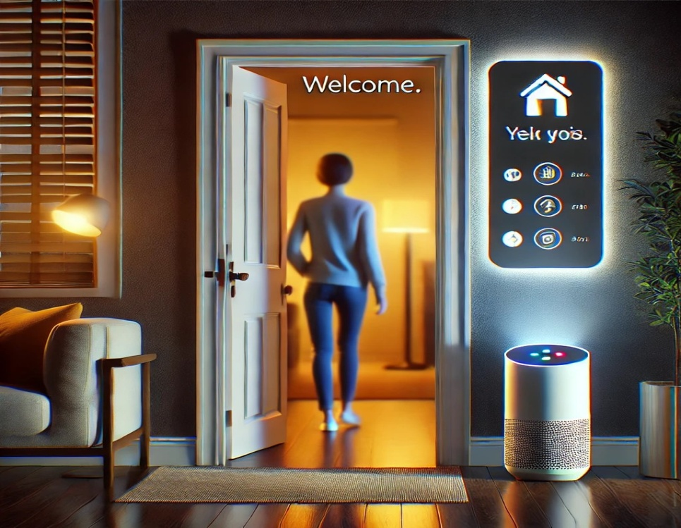

**Voice Command for Daily Summary**

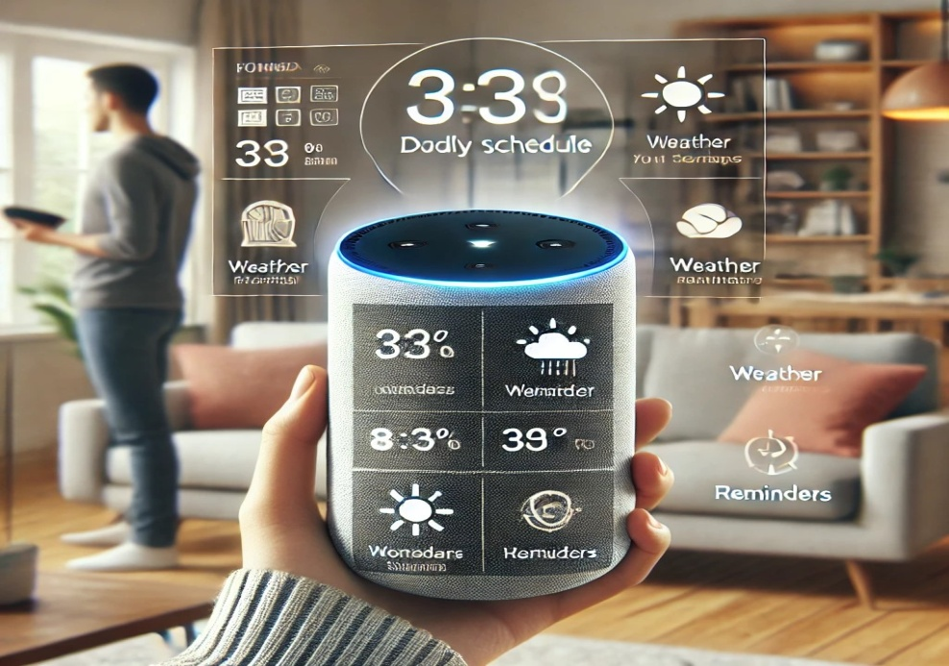

**Smart Home Controls Activation**

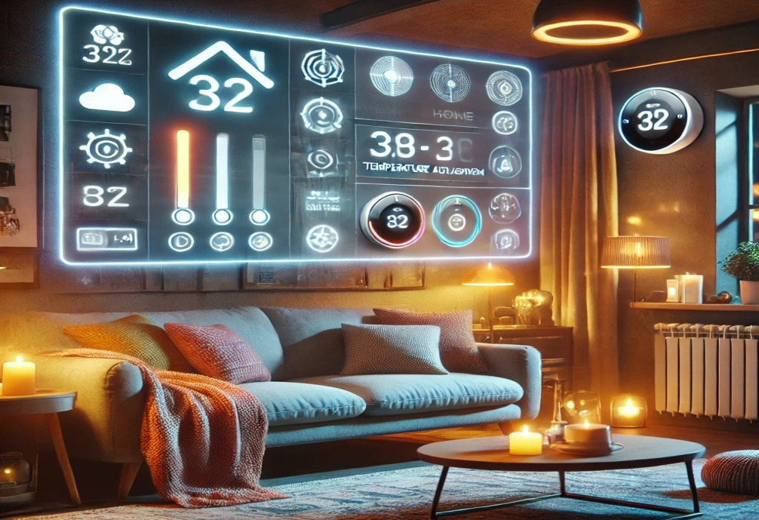

**Security System Check**

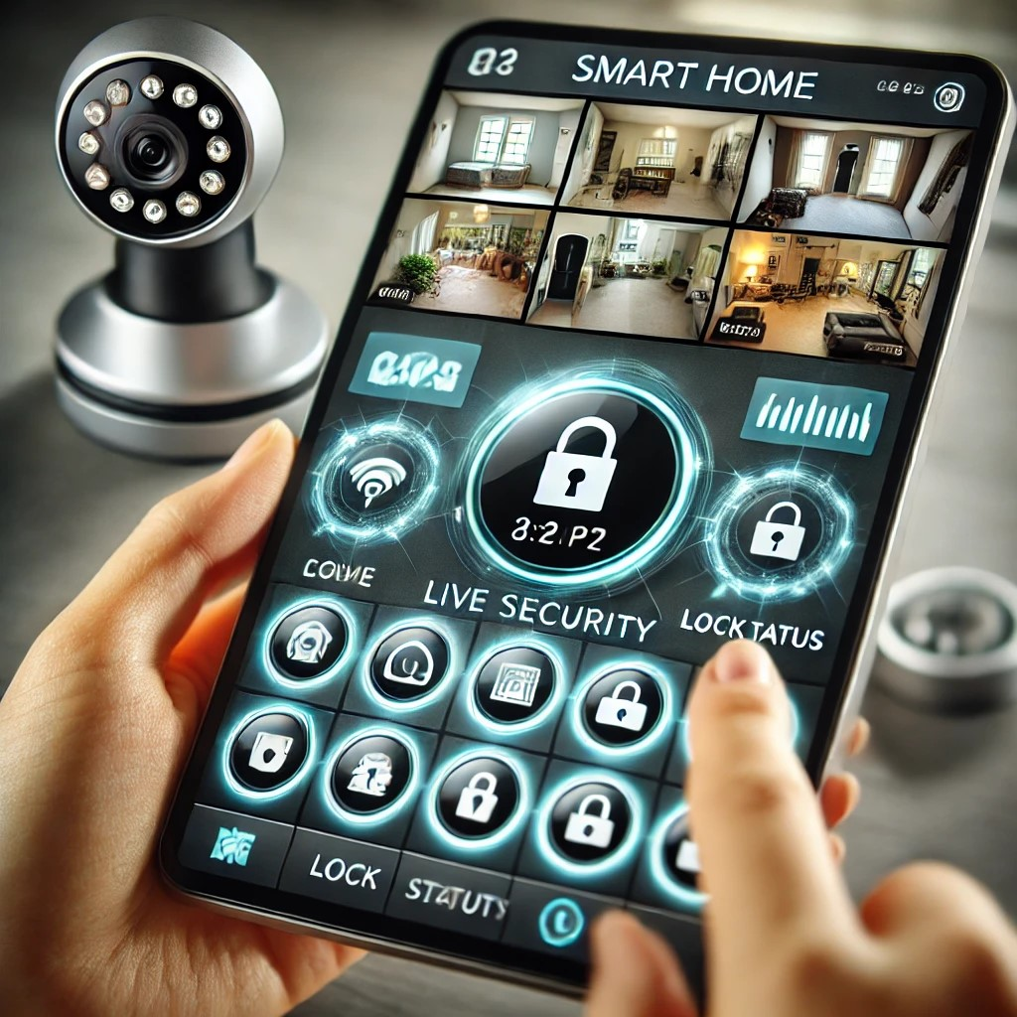

**Cooking Assistance in the Kitchen**

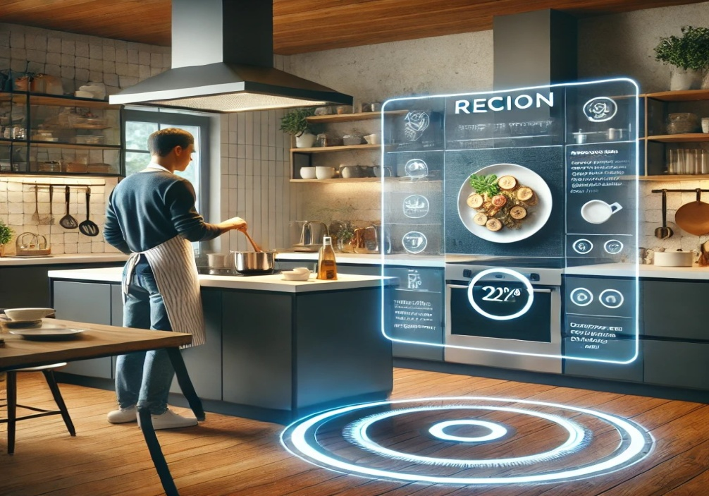

**Evening Relaxation Mode**

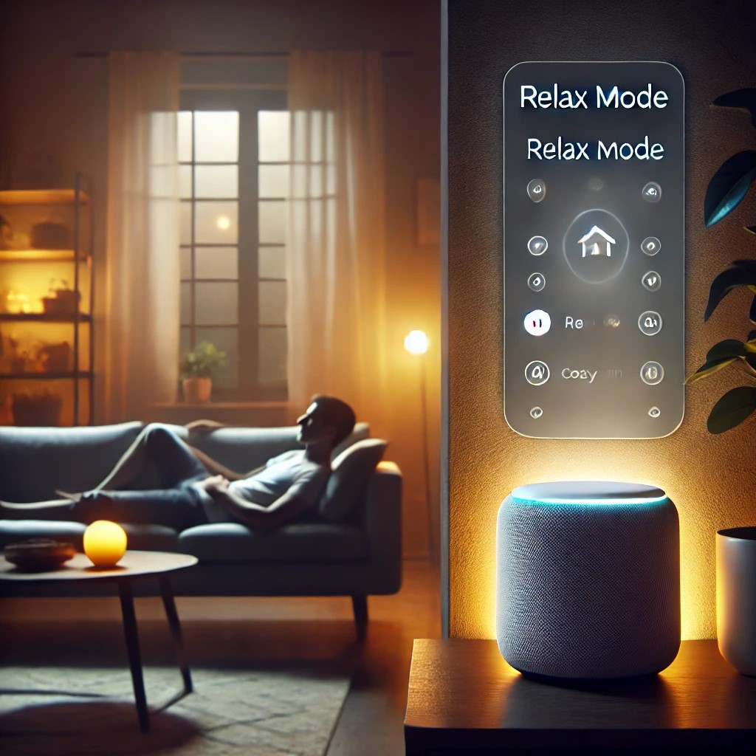

**Good Night Routine**

